Open Source Cubesat Using Commercial Off the Shelf Electronics

(May 2020)

Mark Bright, Zach Cullen, Shawn Nase, and Jimmy Oakes

***Abstract*— Many small scale satellites in current use are either proprietary while low-cost, or high-cost while open source. The development of a microsat as described in this paper was conducted with the aim of realizing an open-source microsat that was low in cost. The novel approach taken to develop a microsat that satisfies these attributes revealed some aspects of the satellite design would work in the intended operating environment while the functionality of other aspects of the design are inconclusive and require further testing and development.**

***Index Terms*— Microsat, Open-source, Low-cost, COTS**

# INTRODUCTION

The objective of this paper is to present a low cost, open source, modular satellite design and support its feasibility with accompanying analysis. In February 2020, the design was initially predicted to take roughly 16 weeks and $1500 to plan, test, and implement. The objective then was to physically implement a commercial off the shelf (COTS) circuit contained within a housing that can consistently operate a clock to blink an LED while subject to the simulated environmental effects of space. Due to limitations imposed by the COVID-19 pandemic, focus has been shifted from an experimental approach to an analytical approach. Analyses and modeling of the satellite’s housing in order to support feasibility under environmental conditions have been conducted. The novel design is intended to promote further research into using alternate electronics for CubeSats, which will ideally continue to drive down costs once thoroughly investigated. If successful, the design will open opportunities for space research to those with exceptionally low funds.

Current satellite designs typically use space rated components. See [6] for specific details regarding space rated components. Such components drive up cost immensely. There has been a push recently for small cube-shaped satellites or ‘CubeSats’, which are generally marketed towards low budget communities such as academics, independent researchers, and hobbyists. In the CubeSat space, the general trend has been to reduce the satellite size, which greatly reduces cost. The range of cost for such satellites is vast, ranging from less than $1000 prelaunch (see [2] for details) to hundreds of thousands of dollars. The lowest cost designs are not yet open source.

Risks associated with the design are primarily environmental effects. Thermal effects are mitigated via an insulated housing design, and calculations supporting the insulation’s ability to deal with thermal effects have been conducted. A pressurized container is used to resolve vacuum effects and minimize gas leakage. Calculations regarding the penetration of ionizing radiation through the casing material have been conducted, and the casing material and thickness selected accordingly.

# Systems Overview

Following COVID-19, the physical implementation of the Tubesat became beyond the scope of this report, but the following is intended to give a detailed overview of all the satellite’s proposed systems, including those which cannot be thoroughly analyzed with computer simulations or mathematical models. Electrical and mechanical designs for the pertinent subsystems are available at [], repository for this project.

All electrical circuitry of the satellite, with the exception of power wires feeding energy from the solar modules into the core, will be implemented on a PCB located in a caddy within the core casing. The PCB will sit atop and be thermally coupled to a bank of Lithium manganese oxide 18650 cells. The electrical systems will be categorized as follows: solar, battery, power management circuit (PMC), and digital processing circuit (DPC).

The solar modules incorporated into the design will consist of six 5” by 5” 3.6 W solar cells, each with 21.8 % efficiency. These solar modules will connect electrically in series prior to being fed to the power management circuit within the core of the satellite.

The battery module of the design will consist of four cylindrical lithium manganese oxide 18650 cells placed in series. Each cell is rated for 3.7 V nominal, 4.2 V fully charged, and 3 V depleted. Therefore, the fully charged voltage of the battery module will be 16.8 V rated for 2.2 AH, and will be considered depleted when the series voltage is approximately 12 V.

The power management circuit (PMC) consists of several subsystems. A single-ended primary-inductor converter (SEPIC) enables voltage up/down conversion through fast MOSFET switching and coupled inductors. Current bypass MOSFETs enable dynamic cell balancing. A microcontroller that uses firmware implemented battery chemistry profiling and SOC determination algorithms allows for high-efficiency energy transfer. This controller mechanism incorporates I2C communications capability that can be modulated onto satellite uplink/downlink data channels.

The digital processing system will consist of an Atmega 2560 IC. This 8-bit microcontroller incorporates 256 KB of flash memory, 8 KB of RAM, and 16 MIPS capability at a clock frequency of 16 MHz while maintaining low power consumption.

For the mechanical design including the outermost housing, the length/width/depth dimensions are expected to be 6” by 6” by 6’’. On the outermost layer, six 1/16” thick aluminum solar panels will form a cube. Within the structure to support the panels, a recession will house an insulated tube that contains the battery, PMC, and DPC modules. The tube will be installed into the internal compartment of the satellite through one of several gaps. The remaining gaps will be of a modular design and allow multiple tubes containing mission equipment to be installed and linked together in terms of power and communication. The core casing will protect the internal electronics and caddy material from ionizing radiation found in space. Hexagonal voids within the printed caddy will provide thermal isolation of interior components. A sealed core casing will allow atmospherically pressurized air to be held inside the container.

The following images are intended to provide a detailed visualization of the Tubesat housing, the subsystem of interest for the analysis presented later in this paper.

# Analysis Results

* 1. *Air Leakage*

A large factor in determining the feasibility of the satellite is the rate at which air leaks out of the core casing. The goal for the six month lifespan of the satellite is to have a pressure of at least 12 psi inside the core casing, in order to ensure the structural integrity of electrical components.

The leak rate of a tube can be obtained from the equation,

$Leak Rate = 0.7*F*D*P*Q*(S^{2})$

where *F* is the permeability rate of air through the silicone o-ring at operating temperature, *D* is the inner diameter of the o-ring, *P* is the pressure differential across the seal, *S* is the percent squeeze on the o-ring cross section, and *Q* is a factor based on the percent squeeze and whether the o-ring is lubricated or dry [7].

The only variables in this equation are the permeability rate and the Q-factor. The permeability rate of air across a silicone o-ring was given at a temperature of 72℉, which is the highest temperature that the satellite will be subjected to in orbit. Using this permeability rate will give us an absolute worst-case scenario of the air loss over the six month lifespan since permeability will decrease as temperature decreases. The Q-factor was taken from a chart provided with the equation and the percent squeeze on the o-ring.

Fig. X

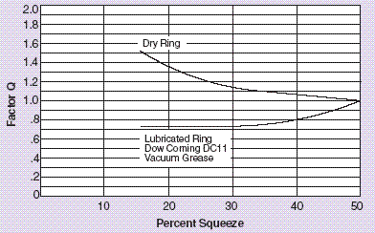

Fig. X shows the Q-factor chart based on the percent squeeze and lubrication of the o-ring.

From this equation, a leak rate of 1.475e-6 cc/sec (cubic centimeters per second) was derived. Over the course of six months, this leak rate would result in the loss of 23.258 cc of air. The core casing has an interior volume of 182.357 cc. Therefore, after six months the core casing would have 159.117 cc of air left, or 12.825 psi, which is above our minimum pressure of 12 psi.

* 1. *Thermal Modeling*

Internal thermal energy transfer via radiation within the 3-dimensional space between the satellite paneling, core casings, and caddies can be ignored. See Fig. X for justification.

Fig. X

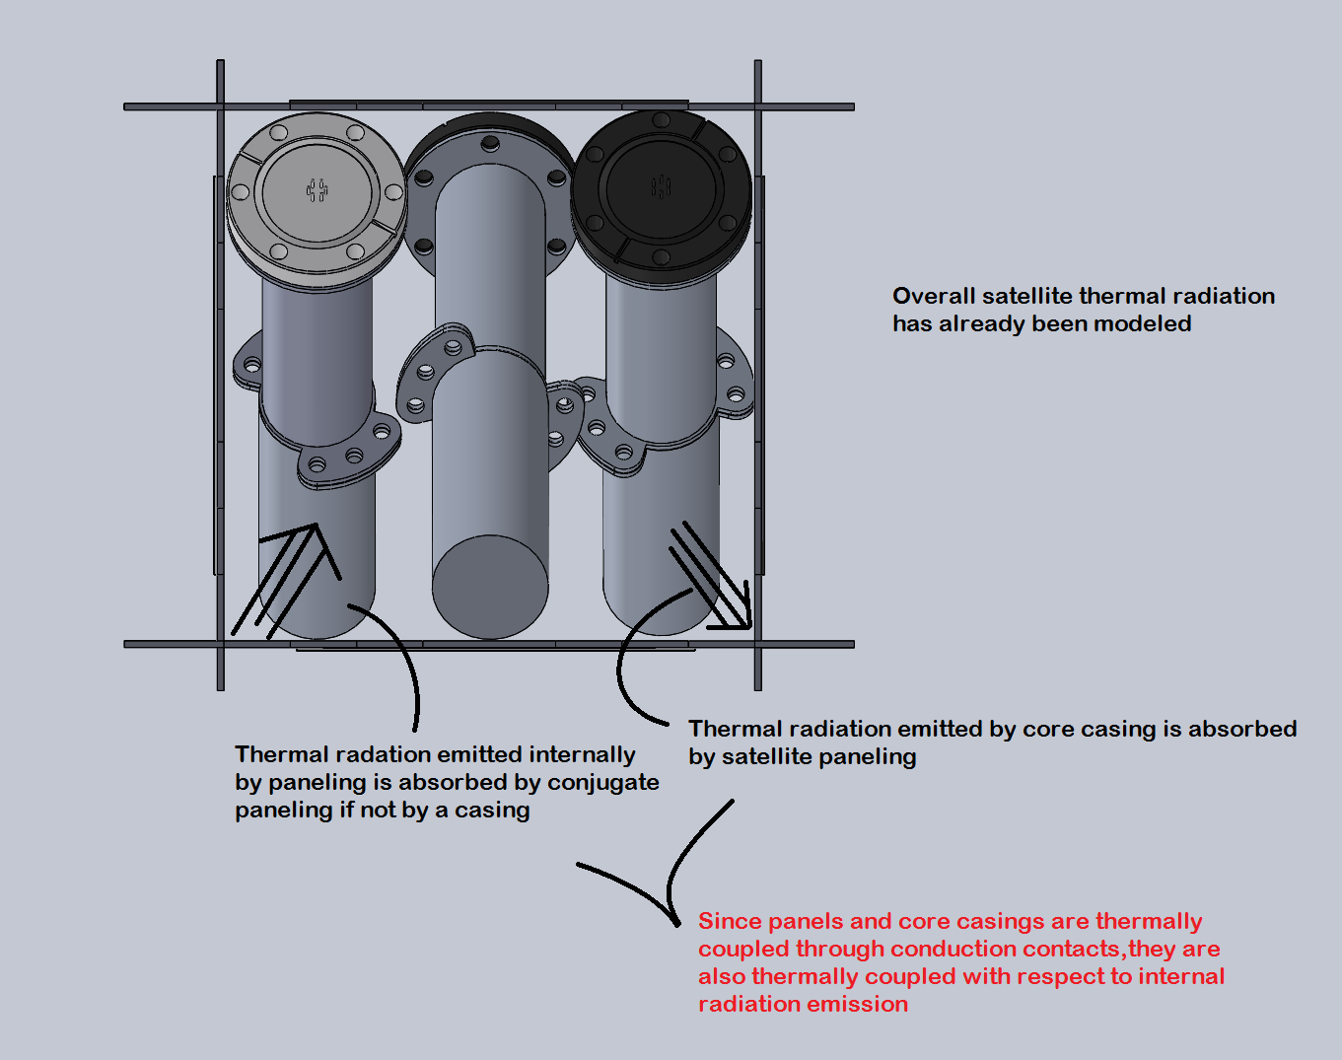

Fig. X provides a visual aid for the reasoning that internal thermal energy transfer via radiation can be ignored.

External thermal energy transfer via radiation must be taken into account in order to determine the satellite equilibrium temperature in sunlight and shade. These equilibrium temperatures are necessary to conduct thermal modeling of convection and conduction (?) in SolidWorks. For the purpose of this modeling, satellite equilibrium temperatures in sunlight and shade were chosen to be 24°C and -75°C, respectively. The calculations that are needed to determine these temperatures are beyond the scope of this paper but are shown in [1].

CFD Analysis - criteria in table/list format, resultant images from analysis with captions

For the following analyses, the tube caddy and core casing were modeled using assumption cylinders, as shown in Fig. X.

Fig. X

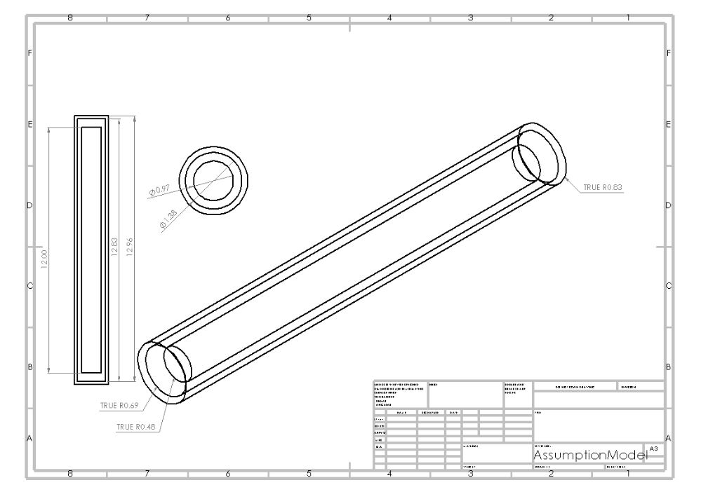

Using the assumption cylinder model, computational fluid dynamics (CFD) analysis was conducted to estimate air molecule trajectories. TABLE X lists the criteria used in the model. The assumption cylinders allow for a symmetrical design. By using no forced convection elements, the analysis was intended to simulate natural convection. The wall heat transfer coefficient was chosen to be artificially high. A high heat transfer coefficient stimulates heat flow, and ideally convective heat transfer should be low, so a high heat transfer coefficient was chosen to simulate a worst case scenario. The CFD analysis results are visually displayed in Fig. X.

TABLE X

|  |
| --- |
| **Criteria for CFD Analysis** |
| Satellite equilibrium temperature in sunlight: 24°C |
| Satellite equilibrium temperature in shade: -75°C |
| Caddy material: ABS Plastic |
| Casing material: 6061-T6 Al |
| Symmetrical design (due to assumption cylinders) |
| No forced convection elements |
| Wall heat transfer coefficient: 500 W/(m^2 * K) |

Fig. X

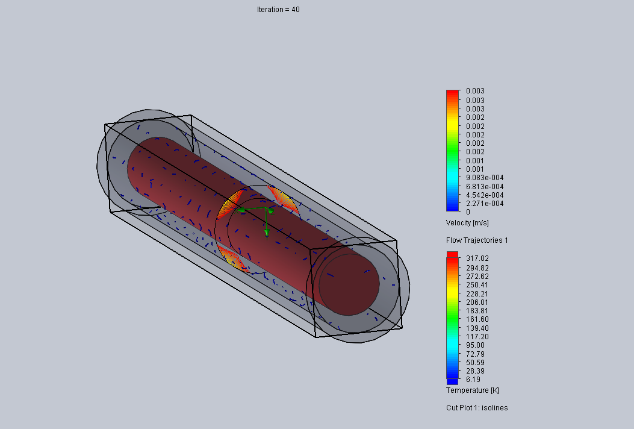

Fig. X depicts a visual representation of the CFD analysis results. Velocity of air molecules in fluid subdomain between caddy assumption cylinder and casing assumption cylinder was less than 0.75 in/s. The air molecule vectors are represented by the blue arrows.

To simulate thermal convection, transient thermal transfer over a 42 min window was simulated using CFD analysis data. The satellite orbit is expected to spend 36 min in the shade, but 42 min was chosen to exaggerate thermal transfer, resulting in a worst case scenario situation. To further exaggerate heat transfer, heat flux at caddy/air and casing/air interfaces was defined as 15 W/m^2. The casing and caddy rotated through several temperature differentials. In each rotation, either the caddy or casing were set as an infinite heat source or bottomless heat sink, again to create a worst case scenario.

The results for thermal convection are shown in TABLE X. As seen in TABLE X, estimated thermal heat transfer magnitude is on the order of picojoules, and can therefore be considered negligible.

TABLE X

|  |  |  |  |  |
| --- | --- | --- | --- | --- |
| **Thermal Convection Results** | | | | |
| **Casing T**  **(F)** | **Caddy T**  **(F)** | **Time**  **(s)** | **Transfer**  **(J)** | **Direction** |
| -100 L | 70 UL | 2520 s | 6.1608E-12 | Ca to CC |
| -100 L | 30 UL | 2520 s | 8.4621E-12 | Ca to CC |
| -100 L | -15 UL | 2520 s | 1.5183E-12 | Ca to CC |
| 70 L | -100 UL | 2520 s | 5.4865E-12 | CC to Ca |
| 30 L | -100 UL | 2520 s | 5.4865E-12 | CC to Ca |
| -15 L | -100 UL | 2520 s | 5.4865E-12 | CC to Ca |
| Note:  L and UL stand for locked and unlocked, respectively  Ca and CC stand caddy and core casing, respectively | | | | |

Thermal Conduction - assumptions in paragraph and table/list format, results in image/paragraph format

Thermal conduction was simulated very roughly. As seen before, the caddy is to be mechanically installed into core casing spaced from casing interior walls via standoffs. These standoffs were modeled as header pins. Under the assumption these header pins contacting casing walls are sanded to a fine point, the resulting contacting surface area per pin was 0.20268347 mm^2. Energy transfer per pin was analyzed at max temperature differential. Thirty standoffs separate the caddy from casing, so the energy transfer per pin was multiplied by 30 to estimate total thermal conduction transfer. Criteria for the conduction simulation are shown in TABLE X.

TABLE X

|  |
| --- |
| **Criteria for Conduction Simulation** |
| Standoff material: Brass |
| Standoff quantity: 30 |
| Standoff surface area: 0.20268347 mm^2 |
| Casing material: 6061-T6 Al |
| Temperature differential: -100°F to 70°F (max) |
| Simulation time: 1 hour |

Subject to the criteria in TABLE X, 0.547 Joules was transferred through one standoff, or 16.41 Joules transferred total in 60 min. The satellite's 92 min estimated orbit consists of 36 min in shade and 56 min in sunlight, so by allocating equivalent ratios of the 60 min orbit to shade and sunlight, it calculated that via thermal conduction, 9.846 J are transferred in shade and 15.316 J are transferred in sunlight during a 92 min orbit. By these results, net positive energy transfer is expected to be preserved via peltier switching. This analysis is admittedly very crude though, and requires more robust experimental testing.

* 1. *Power Budget*

Fig. X: Tubesat in Sun

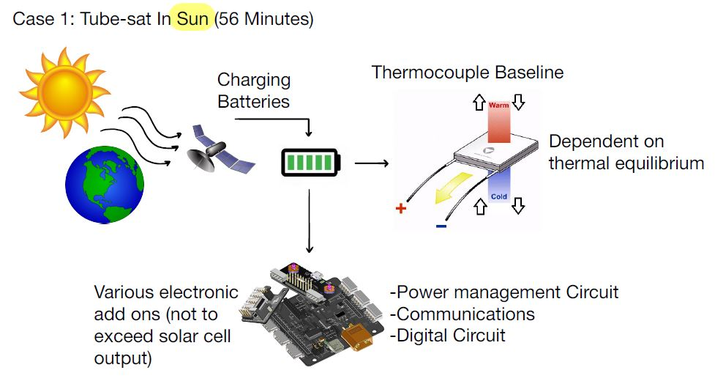

Fig. X serves as a visual guide used for power calculations in the sun.

Fig. X: Tubesat in Shade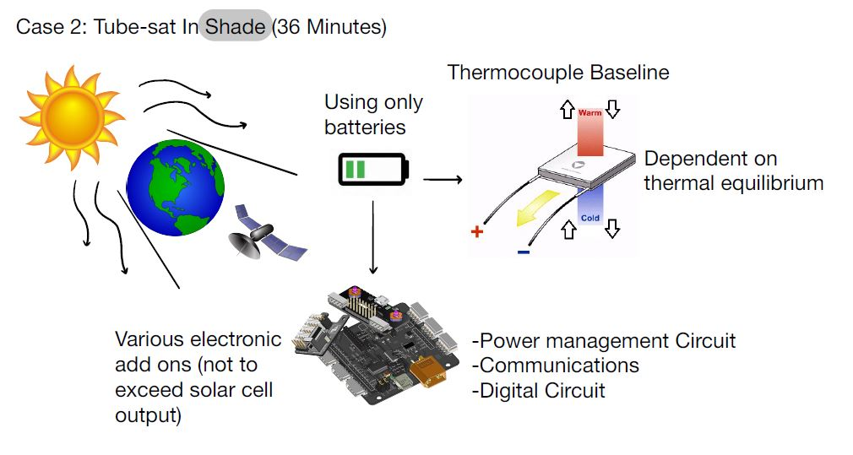

Fig. X serves as a visual guide used for power calculations in the shade.

Within the base satellite system, power is consumed by PMC and DPC subsystems, and provided by the solar cell. Due to time constraints (should we mention cost), a communication system was not planned to be included in the physical satellite implementation intended for testing. For long term functionality, a communication system is still a necessity, so it was factored into power budgeting.

The PMC and DPC modules were physically tested in a lab, and at 5 V drew max currents of 30 mA and 19 mA, respectively. These values were used to determine power consumed, as seen in TABLE X.

A sample communication was set up in the lab, which required a 5 V power source for a USB and drew a max current of 500 mA. These values were used to determine power consumed, as seen in TABLE X.

10 2.5 W solar cells are intended to make up the satellite exterior. Three sides maximum can face the sun while in orbit, so the maximum number of cells exposed to the sun in orbit can be estimated to be five cells. In other words, the satellite’s solar cells can provide 12.5 W of power while fully exposed to sunlight.

Using orbital mechanics, the satellite was estimated to spend 90 minutes in orbit, with 36 minutes in the shade and 56 in sunlight. These values were used to express the power budget in terms of energy.

TABLE X

|  |  |  |  |
| --- | --- | --- | --- |
| **Power Budget** | | | |
| Subsystem | Power Requirement (J/s) | Energy Consumed/Provided in Shade (J) | Energy Consumed/Provided in Sun (J) |
| Communications Power | 2.5 | -8400 | -5400 |
| PMC Power | 0.15 | -504 | -162 |
| DPC Power | 0.095 | -319.2 | -205.2 |
| Solar cell | -12.5 | 0 | 42000 |
| **Total** |  | 15152.4 J | 42000 J |
| **Net Energy Available for Additional Applications:**  26847.6 J | | | |

26847.6 J is sufficient for many applications but should be used frugally. For example, a COTS industrial camera suitable for CubeSat applications consumes 5.1 W maximum (see []). In other words, the camera max energy consumption while in orbit would be 28152 J. Therefore, high energy applications such as live streaming must be limited, but relatively low energy applications such as intermittent photography seem feasible throughout the orbit.

Within the satellite enclosure, there is also room for two more tubes which, as previously noted for the base tube, will consist of four cylindrical lithium manganese oxide 18650 cells placed in series. Ideally, this will provide up to 133,056 J per pack. While this additional energy is not renewable like solar energy, it is still worth mentioning due to its utility in high impulse applications.

# Conclusion

* 1. *Feasibility*

Discussion of feasibility will pertain to concerns that existed prior to the disruption caused by COVID-19. The unconventional nature of the Tubesat electronics has led to difficulties in planning testing in research labs at Penn State.

As mentioned before, the environmental conditions that must be simulated include the vacuum of space, the extreme temperatures of space, and ionizing radiation.

The vacuum of space would be most appropriately simulated in a research lab with a vacuum chamber. Prior to COVID-19, the Student Space Program Lab (SSPL) at Penn State was contacted. Requests to conduct testing in the SSPL were denied due to concerns about the risk of harm to equipment or people. These concerns were justified, considering no prior testing was done with such a design. Therefore, vacuum testing must initially be conducted in a comparatively rudimentary manner. Alternatives

The temperature range associated with the Tubesat’s orbit in space is -100 to 70 °F. Because the high-temperature extreme is within satellite operating temperature, it does not require testing. The extreme cold must be tested because it exceeds the satellite operating temperature range.

Ionizing radiation is not expected to affect the feasibility for reasons stated earlier (see Fig. X).

* 1. *Projected Performance*

The thermal performance of the satellite cannot be determined at this time due to lack of experimental testing data. Preliminary computer based thermal modeling was conducted to find what components regarding satellite thermal behaviour could be not reliably simulated. Although the computer based thermal modeling output data regarding how much thermal energy is transferred from the core casing to the caddy and from the caddy to the core casing, the simulation results need to be supported by laboratory physical testing. Both convection and conduction require physical testing.

Electrical circuits used in the satellite were derived from the Cypress AN2344 application note and electrical circuit schematics made public for the arduino nano device, which consists of an Atmega 2560 IC. The AN2344 application note included evidence of successful circuit operation and successful operation of the arduino nano device is publicly known. The bulk of the satellite electrical system would consist of the AN2344 and arduino nano circuits merged together. It is for this reason that confidence is high that the satellite electrical system would operate reliably provided that standard operating temperature ranges and internal core humidity tolerances apply.

Air gas containment performance is expected to meet project specifications. Calculations regarding air leakage rate revealed that air pressure internal to the core casing does not deviate from standard atmospheric air pressure significantly over the satellite’s intended operating period (6-12 months).

* 1. *Path to Building/Testing in Future Work*

The electrical systems in the Tubesat include the DPC, PMC, battery pack, and solar cells. The battery pack and solar cells have been selected in order to meet the sizing constraints imposed by the core casing, caddy, and 12U standard. The DPC and PMC modules are based on commonly available circuits (Atmega 2560 and ???). The PCB design for both the DPC and PMC must be modified in order to fit within the core casing (sizing). Both of the schematics for these circuits are available online for download but are only compatible with EAGLE. These schematics have been transferred to MultiSim and Ultiboard.

Thermal analysis should be verified experimentally, so this section proposes a potential test. For the components of thermal testing, use two buckets of water with a temperature differential of 170 °F and the fully assembled core with casing segments, o-rings, ceramic feedthrough, and caddy with standoffs.The caddy must have a temperature probe adhered to one of its internal surfaces. The electrical conduit for the probe is recommended to be fed through one of the ceramic feedthrough pins. A computer with capability to convert probe voltage to accurate temperature reading (a compactRIO platform by NI would work) is recommended for this experiment.

For the thermal testing procedure, place one bucket of water containing the fully immersed core in a refrigerator for at least 96 hours, and allow the temperature to drop to approximately 35 °F. Do not allow the water to freeze. Approximately 1 hour prior to conducting the experiment, ignite a propane heater to begin heating the 2nd bucket of water. The temperature of the heated water should reach approximately 205 °F, or just under boiling temperature. When 205 °F water temperature is reached with no more than 5 percent deviation, remove the core from the chilled water and immediately place it into the heated water. Set a timer for 36 minutes. Measure probe temperature in 1 minute increments until the time allotted has expired.

# *References*

[1] D. Dinh, “Thermal Modeling of Nanosat”, San Jose State University, San Jose, CA, USA, 2012.[Online]. Available: <https://scholarworks.sjsu.edu/cgi/viewcontent.cgi?referer=&httpsredir=1&article=7740&context=etd_theses>

[2] Seckel, Scott, and Monique Clement. “The next Big Thing in Space Is Really, Really Small.” ASU Now: Access, Excellence, Impact, ASU News, 2017. [Online]. Available: asunow.asu.edu/20160406-creativity-asu-suncube-femtosat-space-exploration-for-everyone.

[3] Atmel, “Atmel ATmega640/V-1280/V-1281/V-2560/V-2561/V”, 1600 Technology Drive, San Jose, CA 95110 USA, 2014. [Online]. Available: <http://ww1.microchip.com/downloads/en/DeviceDoc/Atmel-2549-8-bit-AVR-Microcontroller-ATmega640-1280-1281-2560-2561_datasheet.pdf>

[4] CYPRESS, “CY8C27143/CY8C27243 CY8C27443/CY8C27543 CY8C27643 PSoC® Programmable System-on-Chip™, 2018. [Online]. Available: <https://www.cypress.com/file/134906/download>

[5] Custom Thermoelectric, “TEC Specification Sheet”, 11941 Industrial Park Road, STE 5, Bishopville, MD 21813, 2018. [Online]. Available: <https://customthermoelectric.com/media/wysiwyg/TEC_spec_sheets/07101-9330-48RF3_spec_sht.pdf>

[6] NASA, “NASA Parts Selection List (NPSL)”, NASA Goddard Space Flight Center, Greenbelt, MD 20771, 2016. [Online]. Available: <https://nepp.nasa.gov/npsl/>

[7] Engineers Edge, “O-Ring Leak Rate Equation and Calculator”. EngineersEdge.com https://www.engineersedge.com/fluid_flow/oring_leak_rate_13605.htm

[8]Cho, Dong-Hyun, “High-Resolution Image and Video CubeSat (HiREV): Development of Space Technology Test Platform Using Low-Cost CubeSat Platform,” Hindawi [Online]. Available: https://www.hindawi.com/journals/ijae/2019/8916416/tab3/